Annie Mae" Jones" Jackson
1919 - 1998
Spouse of: Wilmer S. Jackson
Daughter of: Willie Thomas & Bertha Wadell "Hand" Jones

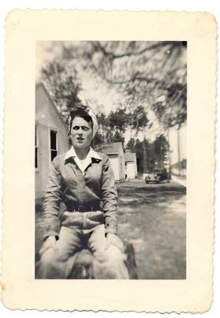  Annie Mae Jones  (Photo 1944)  Shipyard worker |   Wilmer Jackson  (Photo 1944)  US Army Sniper

