Edna V. "Chambliss" King
Spouse of: William 1.King
Daughter of: John & Dessie Chambliss

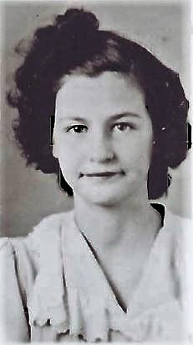
School Days 1943 – 1944

