Elizabeth "Jones" Huff
1840 - 1922
Spouse of: William David Huff
Daughter of: Seaborn & Mary "Adams Jones

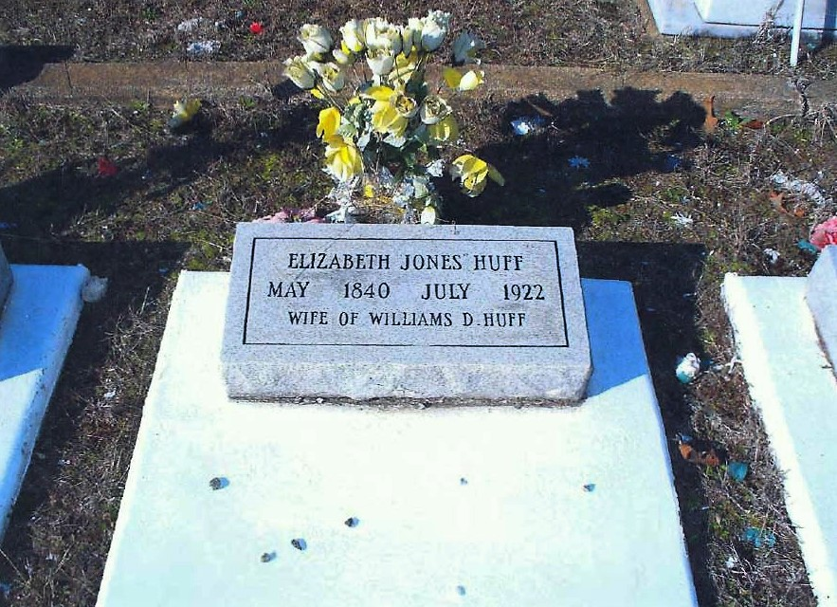

Notes for ELIZABETH JONES:

Elizabeth Jones was born in 1840 and was the second
born child of Seaborn and Mary "Adams" Jones. Seaborn
was responsible for introducing this Jones line to Jackson
County, Florida (circa) 1845. When Elizabeth Jones
married William David Huff in 1869 It was his second
marriage. He brought two sons into the marriage. She
raised William and James as her own. Elizabeth and
William had Thomas, Havilla and the last born, a son
Henry S. Henry S. was born in May 1874 in Jackson
County, Florida. He married a first Cousin RettaJones on
February 06, 1910 in Jackson County. She was the
daughter of Thomas Jones and Eliza Baxter. Retta was
born in August 1888 in Houston County, Alabama. Five
Children were born to Henry and Retta: Nettie B. born in
1911, J.C. born in 1913, W.D. born in 1915, Essie V. born
in 1921 and Elsie born in 1925. All were born in Jackson
County, Florida.

Elizabeth was 18 years older than William David
Huff and outlived him by 41 years. For some reason
when she expired in 1922 she was buried at Friendship a
mile west of Collins where William David is buried.
Research does not indicate she was married after his
death.

Note: On William David's remarks in the Collins survey it
is noted that Elizabeth's headstone is marked in error.
That remark is no longer applicable, her headstone was
corrected to reflect her true death date.

