Emmett S. Jones
1887 - 1963
Spouse of: Minnie Bell "Tidwell" Jones
Son of: James Madison (Jim) & Nancy E. "McMillian" Jones

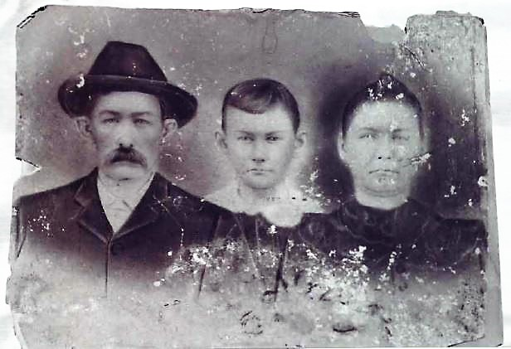
Jim Emmett Nancy (1895)
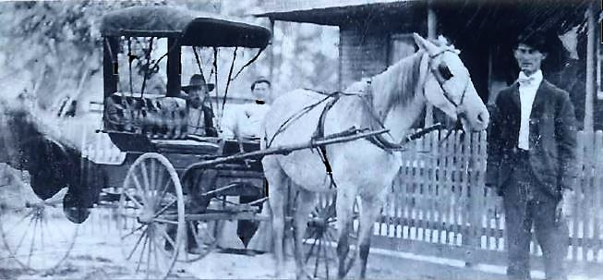

10 Years Later 1905

