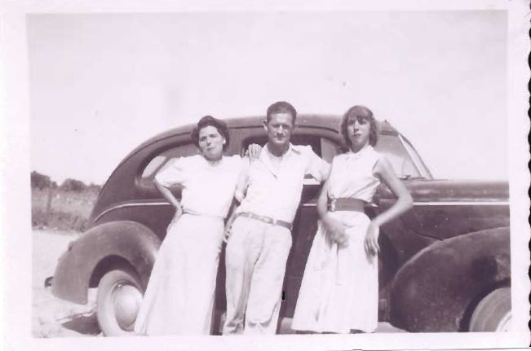

Jay D. King 1911 - 1975
Spouse of: Eva B. "Barrentine” King (on his right)
Sister-in-law: Irene Barrentine (on his left)
Son of: Bud and Ella King

