Madie Estelle" Jones" Petty/McAnulty
Spouse of: Alton B. Petty (Married 1939
Spouse of: James Willard McAnulty (1950)

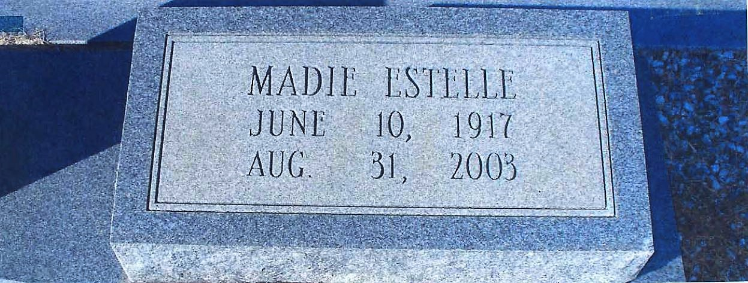

Notes for MADIE ESTELLE JONES:

Madie Estelle's great grandfather "Seaborn Jones" was born in South Carolina in 1819. His father migrated with his family to Muscogee County, Georgia when Seaborn was five years old. They settled on the Chattahoochee River where Seaborn grew up and married Mary Adams. Their fourth born child was Mathew Jones, father of Nathaniel Rite Jones, who was the father of Madie Estelle Jones.

NOTE Worth noting is Madie Estelle's son Pharis Bernard Petty.
Pharis "Bud" in1955 was well filled out for his age, very mature and brilliant. At age fifteen he joined the Navy using a family Bible that contained an altered birth date showing him to be three years older than he was. According to a well known book by Ted Gup (The Book Of Honor) a year later he stood on the deck of the aircraft
carrier USS Badoeng Strait shielding his eyes from a nuclear test. Also according to the book by the time he was based in Vietnam as an army pilot he had earned a Distinguished Flying Cross, A Silver Star, A Bronze Star with Oak Leaf Cluster and an Air Medal with V Device. He was a team leader that led devastating air raids that
sank 174 sampans many loaded with ammo. He retired in 1977 and returned to Florida where he became the owner of Tepper Aviation in Crestview. According to the book he and five crew members were killed in a cargo plane crash in 1989. The book alleges they were delivering a fuselage loaded with supplies (including ammo) in a highly classified operation to Angola Africa, later known as Iran Contra. The book further alleges the C.I.A. coordinated and financed his final mission with destiny. The Book Of Honor is available in most libraries and provides detail information on this tragedy.

NOTE Madie Estelle had a second marriage in 1950. This marriage was to James Willard McAnulty and they were blessed with two son's Games Harold and John). Madie had already been Stricken with one Tragedy prior to her son Bud being killed in Angola Africa. On June 19, 1965 her 14 year old son James Harold was riding on the back of his friend Buddy's motorcycle in Malone, Florida. Buddy's shoe came off which resulted in them losing control of the motorcycle and veering into oncoming traffic. They were struck head-on by a full size automobile. James Harold died with Madie Estelle sitting beside him in an ambulance in route to the hospital. His friend was ejected and not seriously injured.

More About MADIE ESTELLE JONES:
Burial: 2003, Friendship Baptist Cemetery
County, Florida Jackson

