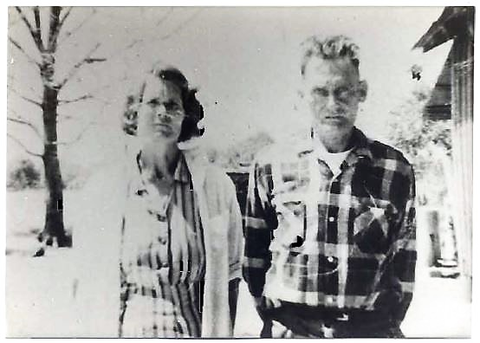
Mary & Jeff (Photo 1962)
Mary Elizabeth "Smith" Jones 1918 - 2001
Spouse of: Thomas Jeff Jones
Daughter of: James S.& Unity "Baxter" Smith

Notes for MARYELIZABETHSMITH:

Mary Elizabeth was the 10th child born to James and
Unity Smith. She married Thomas Jeff Jones in 1935 at
age 17. Thier first born was a son (Roy Thomas) in 1939.
A relocation dispute from Mississippi (by both
admittance) resulted in a divorce. Thomas Jeff moved to
Michigan and Mary returned to her childhood roots in
Jackson County, Florida. After returning to Malone she
met and married John Addis Batson, a decorated war
veteran returning home from the war. A daughter Betty
Jane was born to that marriage in 1947. Mary and John
Addis were only together a short time after Betty Jane
was born. Mary became a single parent until 1957 at
which time she moved to Michigan and remarried
Thomas Jeff. A second son Donnie Joel was born to them
the same year. Mary died in 2001 and was buried beside
Thomas Jeff at Friendship Church Cemetery. As
documents in her life line indicate, Mary's love for her
childhood roots were second only to her family.

