Mary Liller "Jones" Robinson
1884- 1969
Spouse of: Milton Marvin Robinson
Daughter of: Mathew J. & Mary Molly "Scott" Jones
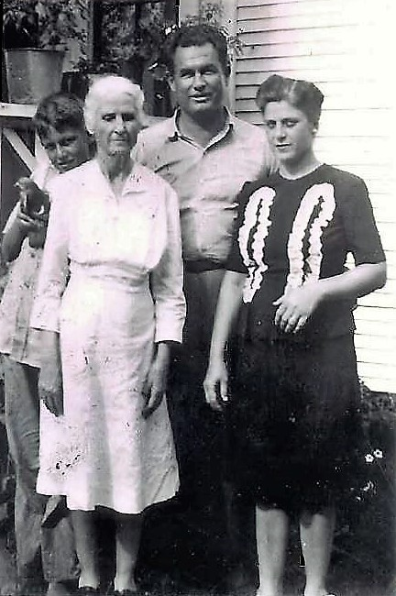
Mary Liller with daughter: Dora Agnes
Son-in-law: Addis Endel Gause
Grandson: Carlos Endel Gause
(Photo 1942)

