Mathew J. Jones 1844- 1910
Spouse of: Mary Molly "Scott" Jones
Son of: Seaborn & Mary "Adams" Jones

Notes for MATHEW J. JONES:

Matthew enlisted in the civil war. He was a confederate soldier from March 1862 to May 1865 serving in Cobbs battery, Stores battalion, Williamson's artillery. He joined in Eufaula Alabama and was honorably discharged at Augusta Georgia on May 26, 1865. Matthew applied for a civil war soldier's pension on August 23 , 1907, and was awarded $120.00 per year. On the application he listed unable to work due to " chronic diesease" .He also listed 2 cows valued at $30.00 with no other personal property shown on the application. The 1880 census indicate Mathew and Mary with son's Arrington 8 years of age and Thomas Warren 5 months old. Also living with them was Mathew's siblings Henrietta 21 and Laura Ann 17. Their parents Seaborn and Mary had died and Mathew had assumed a fatherly roll with them.

Laura Ann "Jones" Murphy  1862 - 1948  The last of eleven children born to Seaborn & Mary  "Adams" Jones.  (Photo 1919) | 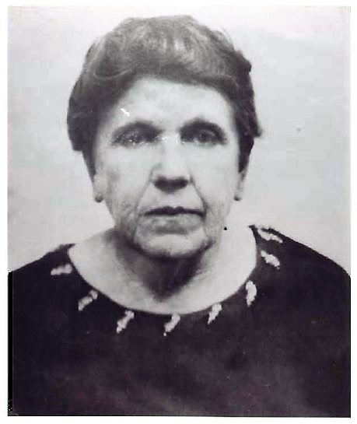

Notes for SEABORN JONES:

Seaborn and Mary were married in 1837 in Columbus Georgia and begin married tife there in Muscogee County. Their first child (Caroline) was born there in 1838 and Elizabeth followed in 1839. In 1840 Seaborn moved his family across the State line to the town of Clayton in Barbour County, Alabama. The 1840 Barbour County census list Seaborn and Mary with two children under five. Also in 1840, Barbour County Court records indicate Seaborn was summoned to serve on jury duty. In 1841 Seaborn was in Barbour County litigation himself. He was awarded 660 dollars in a Civil judgement rendered. Geographically the original connection is not clear but four years later, in 1845 Seaborn and Mary became land owners in Jackson County Florida. Land records indicate they acquired a 60 acre parcel on present day Bump Nose Road at Highway # 162. A second parcel of 240 acres was located on present day Highway # 167 one mile south of Highway # 162. They owned farm land in Jackson County, Florida but continued to live in Barbour County, Alabama. Lucinda, Mathew, Narcissa and Thomas were all born there. Thomas was a one year old in 1850. The Barbour County census taker in July 1850 documented Seaborn, Mary and six children in the household. Between July and December of 1850 Seaborn relocated again, he moved his family to Jackson County, Florida where James (aka) Jim was born in February of 1851. It is apparent this move was considered a mistake because a year later, in 1852 Seaborn and his family had returned to Muscogee County, Georgia. Also in 1852 Jackson County land records indicate Seaborn and Mary sold their 240 acre parcel of land. They received 5,000 dollars cash in the transaction. Through a power of attorney this real estate closing was made from Muscogee County. Records also indicate in 1856 they sold the 60 acre parcel. This sale netted 1,600 dollars cash, and again by power of attorney from Muscogee County. Both contracts were signed by Seaborn and Mary. Records indicate Havilla was born in Muscogee County in 1857, following her was Henneritta in 1859. Apparently in the early part of 1861 Seaborn became restless and decided it was time to move on. This time it was back to Jackson County Florida where in July 1861 Josephine was born. It was 14 months later, On September 12, 1862 in Jackson County Florida (Laura) the eleventh and last child of Seaborn Jones and Mary (Adams) Jones was born. Mary was 41 and Seaborn 42 at the time of Laura's birth. They were obviously very good parents. We know of eleven children Mary gave birth to and all grew up healthy. Research does not indicate any missing before adulthood. Even with all the residential changes Seaborn made in his life, his family was always with him. Considering the times he must have been a very good family provider. Using a term of yester - year apparently Seaborn had decided it was time to settle down. Farming was very lucrative in the area of Bellamy Bridge in this era. It was on part of the Sampson Cox Plantation Seaborn farmed and completed the raising of his family. The last documented contact with Seaborn is a business transaction signed on April 1, 1873. He cosigned on a promissory note with his son Thomas given to Isreal W.T. Baxter (one of Jackson Counties original pioneers). Seaborn is identified on the promissory note as a cotton farmer on the Sampson Cox Plantation. Ironically a few months later Thomas married into the Isreal Baxter family, raising a family of his own and remaining until his death in 1916. The census of 1880 list Heneretta and Laura living with brother Mathew. Apparently both Seaborn and Mary haa died prior to July 1880 when the census was taken. As of this date no head stones or documentation have been found to identify the final resting place of Seaborn or Mary. Perhaps they are buried in unmarked graves in one of the many grown up and abandoned cemeteries in the Bellamy area. May they rest in peace where ever they are.

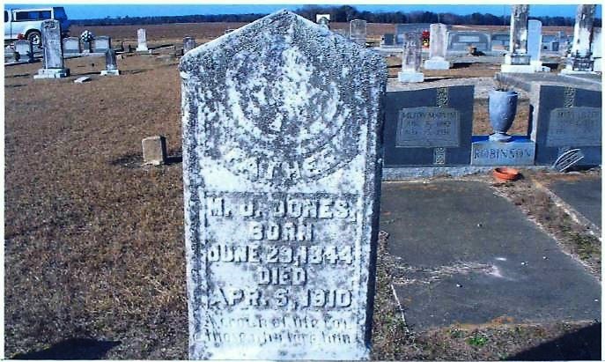

Seaborn Jones  &  Mary "Adams" Jones  Married 1837  Photo (circa) 1855 | 