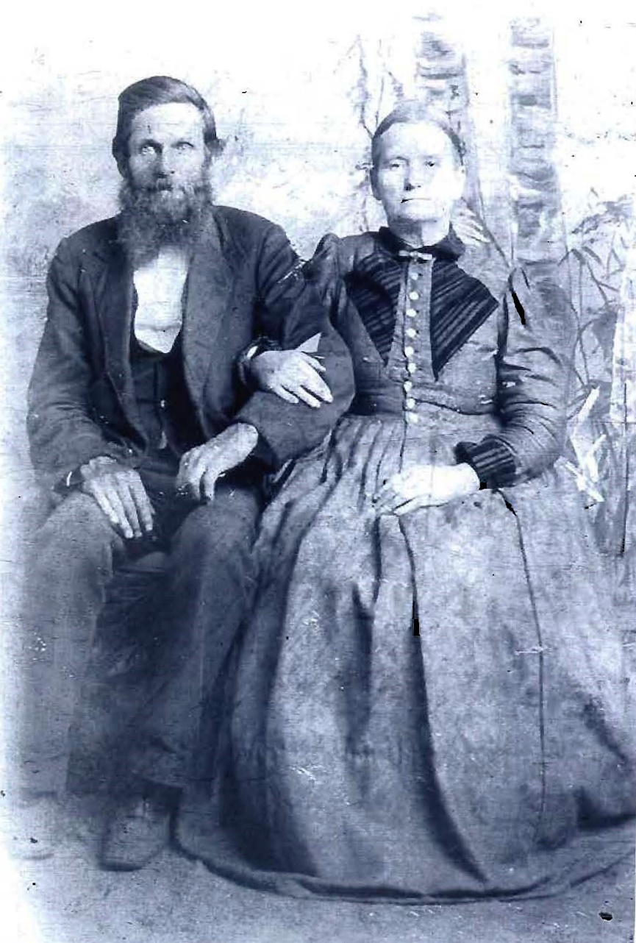

John J. Baxter  June 5, 1832  July 12, 1901  Son of James & Sarah | Rutha E. “Pynes” Baxter  Dec. 7, 1842  Aug 7, 1905  Daughter of White and Sarah

