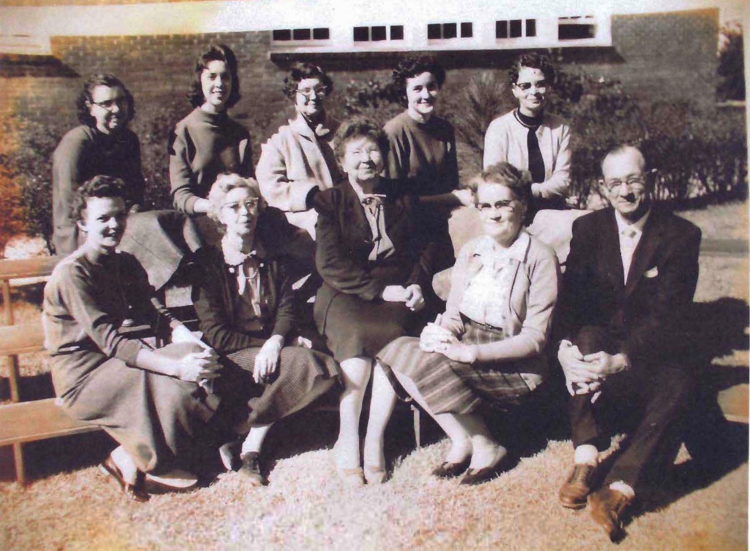Left to right (1958)
Top: Emma Nichols, unnamed, unnamed, Jeanette Dunaway, Gertrude Basford
Lower: Sonja Snipes, Cleo Dominey, MS. Snell, Versie Ford, R.E. Brunson
