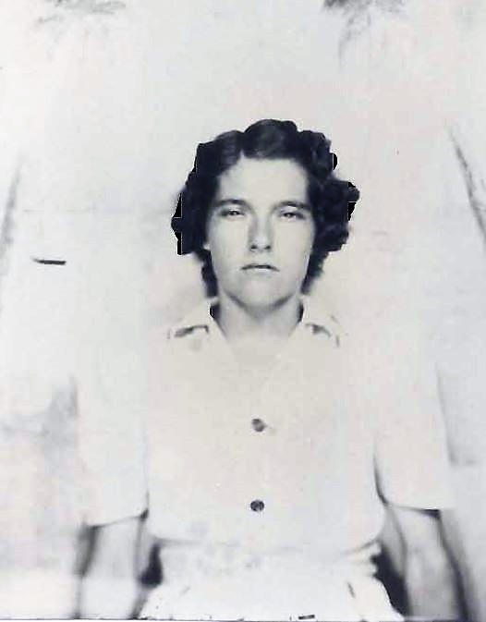
Ruby May "Barrentine" Paulk
Spouse of: Willie (Snooks) Paulk
Daughter of: Richard Cleveland & Callie "Grice" Barrentine

Notes for Ruby Mae Barrentine

On Christmas day 1972 Ruby was struck by tragedy. She lost her husband and 10 year old daughter in a drowning accident. A fishing trip turned tragic when their truck became submerged at the boat ramp. Her husband died trying to save their daughter.

